Experiment :5.1
Fourier Series Analysis of Periodic Signals
OBJECTIVE:
- To analyze Fourier series of continuous-time periodic signals and analyze their waveform characteristics.
- To determine the Fourier coefficients and harmonic components of periodic signals.
- To generate and analyze the amplitude and phase spectra of periodic signals.
- To reconstruct periodic signals using Fourier series and verify the reconstructed waveform with the original signal.
Experimental Procedure:
1. Define the time vector and fundamental frequency.
2. Generate the half-wave rectified sinusoidal periodic signal.
3. Compute the Fourier coefficients up to N = 10.
4. Construct the Fourier-series approximation.
5. Plot the original and reconstructed signals and compare them.
Matlab coding:
clc; clear; close all; %%
5(i) Analysis of Fourier Series Representation of Continuous-Time Periodic Signals figure;
% Fourier Series Representation of a Periodic Signal
A = 1;
f0 = 1;
T = 1/f0;
t = linspace(0, 2*T, 2000);
% Half-wave rectified sinusoidal signal
x = A*sin(2*pi*f0*t);
x(x < 0) = 0;
N = 10;
a0 = (2/T)*trapz(t, x)/2;
an = zeros(1,N);
bn = zeros(1,N);
for k = 1:N
an(k) = (2/T)*trapz(t, x.*cos(2*pi*k*f0*t));
bn(k) = (2/T)*trapz(t, x.*sin(2*pi*k*f0*t));
end
xFS = a0*ones(size(t));
for k = 1:N
xFS = xFS + an(k)*cos(2*pi*k*f0*t) ... + bn(k)*sin(2*pi*k*f0*t);
end
plot(t,x,'k','LineWidth',1.2); hold on;
plot(t,xFS,'r--','LineWidth',1.2);
grid on;
xlabel('Time (s)'); ylabel('Amplitude');
title('Fourier Series Representation of a Periodic Signal');
legend('Original Signal','Fourier Series Reconstruction');
Output:
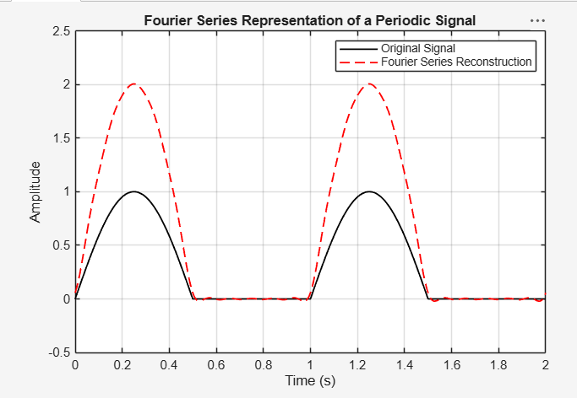
Result:
The impulse response of the discrete-time system y(n)=x(n)+0.5x(n−1) was obtained by applying a unit impulse signal as input. The resulting impulse response was h(n)={1,0.5,0,0,…}, which characterizes the behavior of the system.

EXPERIMENT:5.4
To reconstruct periodic signals using Fourier series and verify the reconstructed waveform with the original signal.
Expected Outcome:
• Reconstruct the periodic waveform using the calculated coefficients.
• Plot original and reconstructed signals together.
• Obtain the reconstruction error.
• Assess the quality of the Fourier-series approximation.
MATLAB Coding:
clc; clear; close all;
%% 5(iv) Verification of Fourier Series Reconstruction and Analysis of Signal Characteristics
figure;
% Fourier Series Reconstruction and Error Analysis
f0 = 1;
T = 1/f0;
t = linspace(0,2*T,4000);
x = max(sin(2*pi*f0*t),0);
N = 10;
a0 = (2/T)*trapz(t(1:2000),x(1:2000));
an = zeros(1,N); bn = zeros(1,N);
tt = t(1:2000); xx = x(1:2000);
for k = 1:N
an(k) = (2/T)*trapz(tt,xx.*cos(2*pi*k*f0*tt));
bn(k) = (2/T)*trapz(tt,xx.*sin(2*pi*k*f0*tt));
end
xr = a0/2*ones(size(t));
for k = 1:N
xr = xr + an(k)*cos(2*pi*k*f0*t) + bn(k)*sin(2*pi*k*f0*t);
end
err = x-xr;
subplot(2,1,1);
plot(t,x,'k',t,xr,'r--','LineWidth',1.1);
grid on; xlabel('Time (s)'); ylabel('Amplitude');
title('Original and Reconstructed Signals');
legend('Original','Reconstructed');
subplot(2,1,2);
plot(t,err,'b'); grid on;
xlabel('Time (s)'); ylabel('Error');
title('Reconstruction Error');
Output:
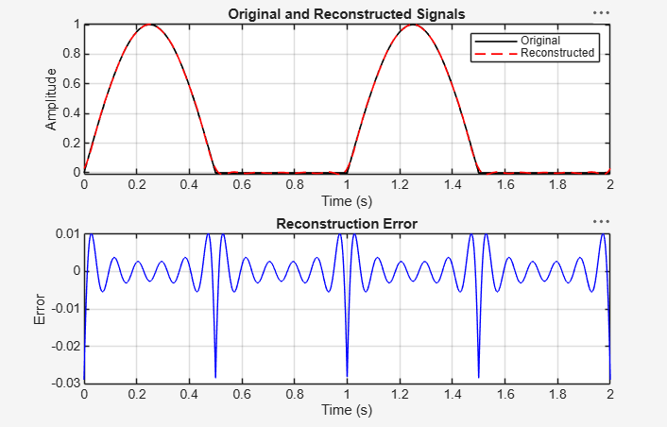
Result:
The discrete-time system described by the difference equation y(n)−0.5y(n−1)=x(n) was analyzed using MATLAB. The output response to a unit step input was obtained and observed to gradually approach the steady-state value of 2, confirming the stable behavior of the system.

Experiment – 6.1
(i) To verify Parseval’s relation for continuous-time periodic signals and analyze the relationship between time-domain and frequency-domain power
OBJECTIVE:
(i)To verify Parseval’s relation for continuous-time periodic signals and analyze the relationship between time-domain and frequency-domain power.
(ii) To analyze the distribution of signal power among the fundamental and harmonic components of periodic signals.
(iii) To determine and analyze the harmonic spectrum of continuous-time periodic signals.
(iv) To compare the total power obtained in the time domain with the harmonic power distribution in the frequency domain.
Experimental Procedure:
• Generate the periodic signal over one period.
• Compute time-domain average power.
• Calculate Fourier coefficients up to N = 20.
• Evaluate frequency-domain power using Parseval’s relation.
• Compare the two values and calculate absolute error.
Matlab coding:
clc; clear; close all;
%% 6(i) Verification of Parseval’s Relation for Periodic Signals
figure;
% Verification of Parseval's Relation
f0 = 1;
T = 1/f0;
t = linspace(0,T,4000);
x = max(sin(2*pi*f0*t),0);
% Time-domain average power
P_time = (1/T)*trapz(t,abs(x).^2);
% Fourier-series coefficients
N = 20;
a0 = (2/T)*trapz(t,x);
an = zeros(1,N); bn = zeros(1,N);
for k = 1:N
an(k) = (2/T)*trapz(t,x.*cos(2*pi*k*f0*t));
bn(k) = (2/T)*trapz(t,x.*sin(2*pi*k*f0*t));
end
% Frequency-domain power using Parseval's relation
P_freq = a0^2/4 + 0.5*sum(an.^2 + bn.^2);
fprintf('Time-domain power = %.6f\n',P_time);
fprintf('Frequency-domain power = %.6f\n',P_freq);
fprintf('Absolute error = %.6e\n',abs(P_time-P_freq));
bar([P_time P_freq]);
set(gca,'XTickLabel',{'Time Domain','Frequency Domain'});
ylabel('Average Power');
grid on;
title('Verification of Parseval''s Relation');
Output:
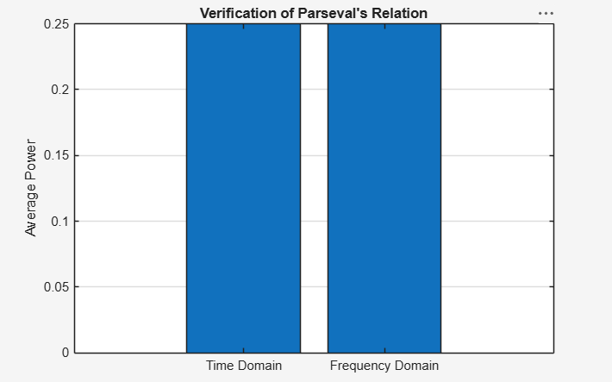
Result:
The convolution of the continuous-time signals x1(t)=e−tu(t) and x2(t)=u(t) was performed successfully using MATLAB. The output signal y(t)=1−e−t was obtained and plotted, demonstrating the convolution operation for continuous-time systems.

EXPERIMENT:(6.4)
(iv) To compare the total power obtained in the time domain with the harmonic power distribution in the frequency domain.
Expected Outcomes:
• Calculate time-domain power.
• Calculate DC and harmonic power components.
• Obtain total frequency-domain power.
• Compare time-domain and frequency-domain results.
Experimental Procedure:
• Generate the periodic signal and compute Fourier coefficients.
• Calculate harmonic magnitude for n = 1 to 15.
• Convert harmonic number to frequency.
• Plot the harmonic spectrum using a stem plot.
• Identify the significant components.
MATLAB Coding:
clc; clear; close all;
%% 6(iv) Comparison of Time-Domain Power with Frequency-Domain Harmonic Power figure;
% Time-Domain and Frequency-Domain Power Comparison
f0 = 1; T = 1/f0;
t = linspace(0,T,4000);
x = max(sin(2*pi*f0*t),0);
P_time = (1/T)*trapz(t,x.^2);
N = 20;
a0 = (2/T)*trapz(t,x);
an = zeros(1,N); bn = zeros(1,N);
for k = 1:N
an(k) = (2/T)*trapz(t,x.*cos(2*pi*k*f0*t));
bn(k) = (2/T)*trapz(t,x.*sin(2*pi*k*f0*t));
end
P_dc = a0^2/4;
P_harmonics = 0.5*sum(an.^2+bn.^2);
P_frequency = P_dc + P_harmonics;
fprintf('Time-domain power = %.6f\n',P_time);
fprintf('DC power = %.6f\n',P_dc);
fprintf('Harmonic power = %.6f\n',P_harmonics);
fprintf('Frequency-domain power = %.6f\n',P_frequency);
bar([P_time P_frequency]);
set(gca,'XTickLabel',{'Time Domain','Frequency Domain'});
ylabel('Average Power'); grid on;
title('Time-Domain vs Frequency-Domain Power');
Output:
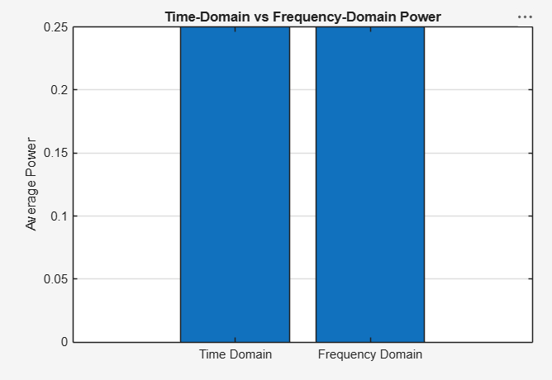
Result:

Experiment – (7.2)
(ii) To determine the magnitude and phase spectra of continuous-time signals and analyze their significant spectral components.
Expected Outcomes :
• Generate the Gaussian-modulated cosine signal.
• Compute its Fourier transform approximation.
• Plot magnitude and phase spectra. • Identify the principal spectral peaks.
Experimental Procedure:
• Define t and the sampling interval.
• Generate x(t)=e^(−t²)cos(2π3t).
• Compute the FFT-based transform with N = 4096.
• Plot the signal, magnitude and unwrapped phase.
• Identify the principal spectral peaks.
MATLAB Coding:
clc; clear; close all;
%% 7(ii) Determination of Magnitude and Phase Spectra of Continuous-Time Signals figure;
% Magnitude and Phase Spectrum of a CT Signal
t = -2:0.001:2;
dt = t(2)-t(1);
x = exp(-t.^2).*cos(2*pi*3*t);
N = 4096;
X = fftshift(fft(x,N))*dt;
f = (-N/2:N/2-1)/(N*dt);
magX = abs(X);
phaseX = unwrap(angle(X));
subplot(3,1,1);
plot(t,x); grid on;
xlabel('Time (s)'); ylabel('Amplitude');
title('Continuous-Time Signal');
subplot(3,1,2);
plot(f,magX); xlim([-10 10]); grid on;
xlabel('Frequency (Hz)'); ylabel('|X(f)|');
title('Magnitude Spectrum');
subplot(3,1,3);
plot(f,phaseX); xlim([-10 10]); grid on;
xlabel('Frequency (Hz)');
ylabel('Phase (rad)');
title('Phase Spectrum');
Output:
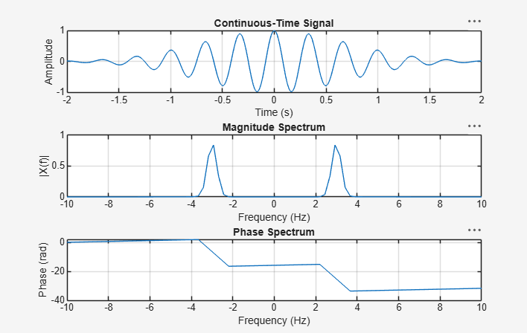
Result:

EXPERIMENT:(7.3)
(iii) Verification of Fourier Transform Properties and Frequency-Domain Characteristics
Expected Outcomes :
• Generate a shifted version of a Gaussian signal.
• Compute the Fourier transform of the shifted signal.
• Calculate the theoretical shifted transform.
• Compare magnitude and phase responses.
Experimental Procedure:
• Generate x(t)=e^(−t²).
• Create x(t−0.4) using interpolation.
• Compute the FFT of the shifted signal.
• Form the theoretical transform using the time-shift property.
• Compare computed and theoretical magnitude and phase.
MATLAB Coding :
clc; clear; close all;
%% 7(iii ) Verification of Fourier Transform Properties and Frequency-Domain
Characteristics
figure;
% Verification of Fourier Transform Properties
t = -2:0.001:2;
dt = t(2)-t(1);
x = exp(-t.^2);
x_shift = interp1(t,x,t-0.4,'linear',0);
X = fftshift(fft(x))*dt;
N = length(x);
f = (-N/2:N/2-1)/(N*dt);
% Time-shift property:
x(t-t0) <-> X(f)e^(-j2*pi*f*t0)
X_shift_theory = X.*exp(-1j*2*pi*f*0.4); X_shift = fftshift(fft(x_shift))*dt;
subplot(2,1,1);
plot(f,abs(X_shift),f,abs(X_shift_theory),'--');
xlim([-5 5]); grid on;
xlabel('Frequency (Hz)'); ylabel('Magnitude');
title('Time-Shift Property: Magnitude Comparison'); legend('Computed','Theoretical'); subplot(2,1,2);
plot(f,unwrap(angle(X_shift)),f,unwrap(angle(X_shift_theory)),'--');
xlim([-5 5]); grid on;
xlabel('Frequency (Hz)'); ylabel('Phase (rad)');
title('Time-Shift Property: Phase Comparison');
legend('Computed','Theoretical');
Output:
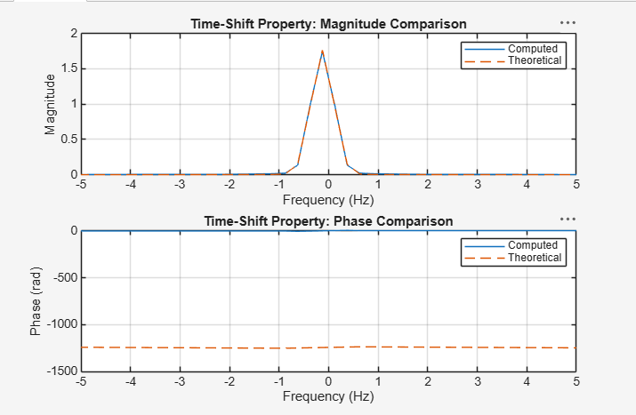
Result:
The Fourier Transform of the continuous-time signal x(t)=e−∣t∣ was computed using MATLAB. The magnitude spectrum was obtained using FFT and showed that most of the signal energy is concentrated around the zero-frequency component, illustrating the frequency-domain representation of the signal.

EXPERIMENT:(8.2)
(ii) Determination of Inverse Laplace Transform for Signal Reconstruction

Expected Outcomes:
• Obtain x(t) from X(s).
• Display the inverse-transform expression.
• Evaluate the reconstructed waveform numerically.
• Analyze the resulting time-domain response..
Experimental Procedure :
• Define X(s) symbolically.
• Apply ilaplace to obtain x(t).
• Evaluate x(t) over 0≤t≤5 s.
• Plot the reconstructed time-domain signal. Observe plot
• Compare the plotted response with the analytical expression.
MATLAB Coding:
clc; clear; close all;
Qualitative %% 8(ii) Determination of Inverse Laplace Transform for Signal Reconstruction
figure;
% Inverse Laplace Transform
% Requires Symbolic Math Toolbox
syms s t
X = 1/((s+2)*(s+3));
x = ilaplace(X,s,t);
disp('Inverse Laplace Transform x(t) =');
pretty(x);
tt = 0:0.001:5;
xx = double(subs(x,t,tt)); plot(tt,xx,'LineWidth',1.2);
grid on;
xlabel('Time (s)');
ylabel('Amplitude');
title('Signal Reconstructed using Inverse Laplace Transform');

Output:
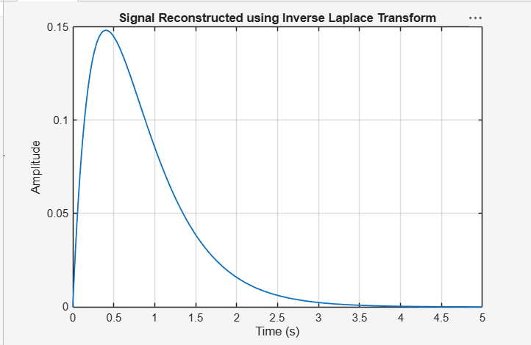
Result:
The Discrete-Time Fourier Transform (DTFT) of the sequence x(n)={1,2,3,4} was computed using MATLAB. The magnitude spectrum was obtained and plotted, illustrating the frequency domain representation of the discrete-time signal.

EXPERIMENT:(8.3)
(iii) To determine the Region of Convergence (ROC) of Laplace transforms and analyze its significance in characterizing continuous-time signals and systems.
Expected Outcomes:
• Identify poles at s = −2 and s = −4.
• State the possible ROC cases.
• Relate each ROC to the corresponding signal sidedness.
• Interpret how ROC affects the system representation.
Experimental Procedure
• Define the pole locations.
• Plot the poles in the s-plane.
• Mark the vertical lines through the poles. Record result
• State the candidate ROC for each signal-sidedness case. • Interpret the relationship between poles and ROC.
MATLAB Coding
clc; clear; close all;
%% 8(iii ) Analysis of Region of Convergence (ROC) and Its Significance in System
Analysis
figure;
% ROC Analysis for a Rational Laplace Transform
% Requires Symbolic Math Toolbox
% X(s) = 1/((s+2)(s+4))
% Poles are at s = -2 and s = -4.
p = [-2 -4];
plot(real(p),imag(p),'rx','MarkerSize',10,'LineWidth',2);
hold on; xline(-2,'--'); xline(-4,'--');
grid on;
xlabel('Real(s)'); ylabel('Imag(s)');
title('Poles and Candidate Regions of Convergence');
legend('Poles','Pole at -2','Pole at -4');
fprintf('Poles are at s = -2 and s = -4.\n');
fprintf('For a right-sided signal, ROC: Re(s) > -2.\n');
fprintf('For a left-sided signal, ROC: Re(s) < -4.\n');
fprintf('For a two-sided signal, ROC: -4 < Re(s) < -2.\n');
Output:
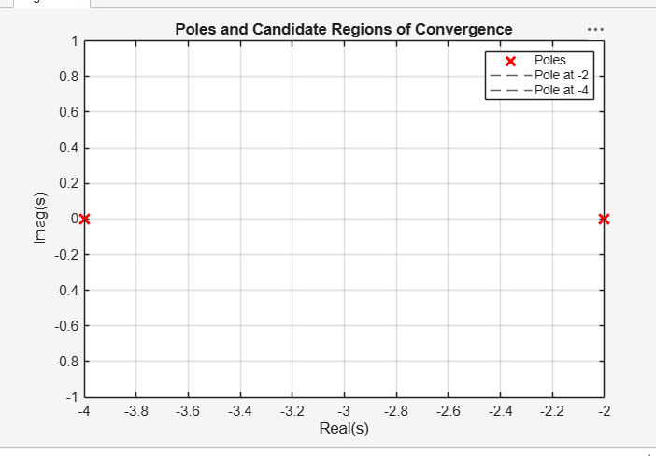
Result:
The DTFT of a rectangular pulse was computed using MATLAB. The magnitude spectrum exhibited a sinc-like shape with a dominant main lobe and diminishing side lobes, demonstrating the frequency-domain characteristics of a finite-duration rectangular sequence.

